**Report**

*Table of Content*

1. **Introduction**

1.1. **Project Description:.......................................................... 3**

1.2. **Technology Used................................................................. 3**

1.2.1. **Hyper Text Markup Language ..................................... 3**

1.2.2. **Java Script ...................................................................... 4**

1.2.3. **Cascading Style Sheets (CSS) ....................................... 5**

1.2.4. **MySQL ..................................................................... 6**

1.2.5. **GSAP .......................................................................... 6**

2. **Project life cycle .................................................................. 7**

3. **Usage scenario ....................................................................... 9**

3. **Hardware &** **Software requirement .................................. 10**

4. **UML use case Diagram...................................................... 11**

7. **References**

**1. Introduction**

**1.1.** **Project Description**

E-commerce is fast gaining ground as an accepted and used business paradigm. More and more

business houses are implementing web sites providing functionality for performing commercial

transactions over the web. It is reasonable to say that the process of shopping on the web is becoming commonplace.

The objective of this project is to develop a general purpose e-commerce store where any product can bebought from the comfort of home through the Internet.

However, for implementation purposes, this paper will deal with an online book store.

An online store is a virtual store on the Internet where customers can browse the catalog and select

products of interest. The selected items may be collected in a shopping cart. At checkout time, the

items in the shopping cart will be presented as an order. At that time, more information will be

needed to complete the transaction. Usually, the customer will be asked to fill or select a billing

address, a shipping address, a shipping option, and payment information such as credit card number.

An e- mail notification is sent to the customer as soon as the order is placed.

**1.2.** **Technologies Used**

**1.2.1. Hyper Text Markup Language (HTML)**

Hypertext Markup Language (HTML) is a language for describing how pages

of text, graphics, and other Information are organized, formatted, and linked

together. It is not really a programming language in the sense of COBOL or

Visual Basic, but it does provide powerful capabilities for text formatting and

output display. The original purpose of HTML was primarily as a tool for

making text documents readily available on the Internet. Basic graphic support

was added, and the things started to take off. Now we have sound, live video,

retail catalogs, and much, much more available to us.

HTML pages are the standard interface to the Internet. This basic language provides the necessary nuts and bolts for building Web pages.

HTML stands for Hyper Text Markup Language and was developed specifically for use on the

system of links, which can be non sequential in order. HTML is not a programming language. It is a marking up language used for linking one piece of information to another.

Using a markup language means that tags can be added to the words in the document and web enable

them. A tag is a set of descriptive formatting codes used in HTML document that instructs a web

browser how to display text and graphics on a web page.

HTML 2.0 is the first standard of HTML specification, released in 1996. HTML 3.6 was the next

specification to be developed. It was a joint effort of many software companies like Microsoft, IBM, Sun Microsystems, Novell and others.

**1.2.2.** **JavaScript**

The project uses JavaScript as the client side scripting language for JSP/HTML pages in the project. JavaScript is an easy to use object-scripting language designed for creating live online applications that link together resources on both clients and servers. JavaScript is designed for use by HTML page authors and enterprise application developers to dynamically script the behavior of objects running on either the client or the servers. JavaScript ‘s design and concept represent the next generation of software for the Internet and is:

 Designed for creating network centric applications

 Complementary to and integrated with Java

 Complementary to and integrated with HTML

 Open and cross platform

JavaScript is a platform-independent, event driven, interpreted programming language developed by Netscape Communications Corp. and Sun Microsystems. Originally called Livescript, JavaScript is a programming language that can be included on web pages to make them more interactive.

JavaScript is easier to understand, less complex version of its distant cousin, Java. It is a text-based language that must be placed within HTML that must be placed within, HTML, to be read by the browser and interpreted so the instructions can be performed.

JavaScript is a preferred language for client side scripting. This is mainly because when client side

scripting is done browser compatibility is an issue of concern and both major browsers support

JavaScript.

**1.2.3. Cascading Style Sheets (CSS)**

Cascading Style Sheets (CSS) is a style sheet language used for describing the presentation of a document written in a markup language such as HTML. CSS is a cornerstone technology of the World Wide Web, alongside HTML and JavaScript.

CSS is designed to enable the separation of presentation and content, including layout, colors, and fonts. This separation can improve content accessibility; provide more flexibility and control in the specification of presentation characteristics; enable multiple web pages to share formatting by specifying the relevant CSS in a separate .css file, which reduces complexity and repetition in the structural content; and enable the .css file to be cached to improve the page load speed between the pages that share the file and its formatting.

Separation of formatting and content also makes it feasible to present the same markup page in different styles for different rendering methods, such as on-screen, in print, by voice (via speech-based browser or screen reader), and on Braille-based tactile devices. CSS also has rules for alternate formatting if the content is accessed on a mobile device.

The name cascading comes from the specified priority scheme to determine which style rule applies if more than one rule matches a particular element. This cascading priority scheme is predictable.

The CSS specifications are maintained by the World Wide Web Consortium (W3C). Internet media type (MIME type) text/css is registered for use with CSS by RFC 2318 (March 1998). The W3C operates a free CSS validation service for CSS documents.

In addition to HTML, other markup languages support the use of CSS including XHTML, plain XML, SVG, and XUL.

**1.2.4.** **MySQL (Database)**

MySQL is a relational database management system based on SQL – Structured Query Language. The application is used for a wide range of purposes, including data warehousing, e-commerce, and logging applications. The most common use for mySQL however, is for the purpose of a web database.

**1.2.5.** **GSAP**

GSAP is a suite of tools for scripted animation. It includes: The GSAP core - The core of the engine which animates any property of any object. It makes use of tweens and to give you more control over your animations.

**2.1 Software Development Life Cycle:**

Software development organization follows some process when developing a

software product. A key component of any software development process is the life

cycle model on which the process is based. The particular life cycle model can

significantly affect overall life cycle costs associated with a software product. Life

cycle of the software starts from concept exploration and at the retirement of the

software.

**Software Development Life Cycle**

**PHASES OF SYSTEM DEVELOPMENT LIFE CYCLE:**

The system development life cycle is classically thought of as the set of

activities that analysts, designers and users carry out to develop and implement

an information system. The system development life cycle consists of the

following activities:

* Preliminary investigation.
* Requirement Analysis.
* System Designing.
* Coding.
* System Testing.

**Preliminary Investigation : -**

An important outcome of the preliminary investigation is the determination that

system is feasible or not. In the conduct of feasibility study, there are three

major distinct and interrelated areas were taken into consideration.

**Requirements analysis :-**

Analysis of requirements includes studying the existing system and collecting

data. During analysis, data are collected on the available files, decision points

and transaction handled by the present system. Once the structured analysis is

completed, the analyst has affirmed understanding of what is to be done.

**System Designing:**

The design of an information system produces the details that clearly describe

how a system will meet the requirements identified during system analysis.

System analysts begin the design process by identifying reports and other

outputs system will produce. The system design also describes the data to be

input, calculated or stored.

**Coding : -**

This is the phase in which computer based system is constructed from the

specifications prepared in the design phase. Equipment is acquired and installed

during the development phase. All necessary procedure, manuals software

specifications, and other documentation are completed. The staff is trained.

**System Testing:-**

During system testing, the system is used experimentally to ensure that the

software does not fail. In other words we can say that it will run according to

its specifications and in the way users expect. Special test data are input for

processing, and the result examined.

**Usage Scenario:**

This section provides a usage scenario for the software. It organized information

collected during requirements elicitation into use-cases.

1. **User Profiles:**

There will be three levels of users:

Administrator level (Employee)

User level (Account Holder)

1. **Use-cases:**

**Administrator level:**

This level of users will be able to insert new Books, new Category and Price

information,. They will also be able to generate

**User Level:**

This level of users will be able to Search the books, Order the books etc. They can

view their records.

1. **Hardware Requirement**:
2. **Server (Windows Server (NT))**

Microsoft Server is based on NT Technology biased to run server

side scripts in ASP technology.

Disk Space 1 GB.

Web Server Microsoft

1. **Client**

Disk Space 1GB.

Processor Intel Core i5

Processor Speed 1.50Ghz

Memory 256 MB

1. **Software Requirement:**

**Operating System** : Windows 2010 , linux

**Technologies :** Sublime

**Client Side Scripting Language** : HTML and JSP and Java.

**Server Side Scripting Language :** JSP

**Markup Language :** HTML

**Database Server** : MySQL

**UML use case Diagram**

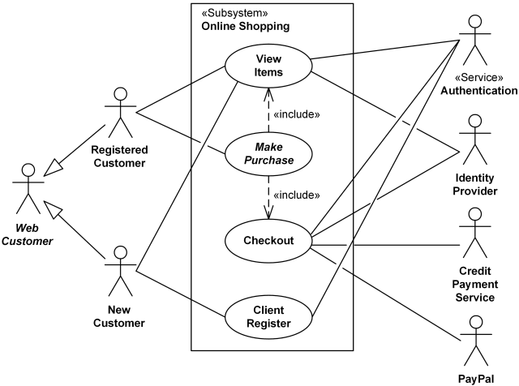

**References**

* [**https://en.wikipedia.org**](https://en.wikipedia.org)
* [**https://www.uml-diagrams.org**](https://www.uml-diagrams.org)
* [**https://greensock.com/**](https://greensock.com/)
* **Naughton Schildt, Complete Reference Java 2, Third Edition,**